Appendix A: File Name: Survey for FY 20xx - Example.docx.

Southeastern Air Pollution Control Agencies
Upcoming Training Course Needs (FY 20xx)

Please indicate in the table below your best estimate of priority training needs for the 12-month period from October 1 of the new Fiscal Year through September. Please note that final determinations of courses held will be subject to overall demands in the region, Metro 4/SESARM staff support resources, available training funds, and any grant complications. Preferably, the courses listed below will have adequate demand (each likely to have 15 or more students) to justify holding in your area.

Some of the lines have been pre-filled in response to conversations with some agency training-coordinators. Please confirm these needs and correct the students count need. Except where annotated these courses do not include course that are already scheduled and posted on the Learning Management System (LMS).

It would be helpful if the training coordinator for each of the state air program agencies would contact any associated state support agencies (e.g., permitting, enforcement, field operations, etc.) or local training coordinator(s) to finalize the requested information. State support agency training coordinators and locals may also contact the state training coordinator to initiate this conversation if you wish.

The catalog of NACT and APTI Core Courses that are routinely offered is part of this document. If you have something to add please let us know. This catalog is on the next page of this document.

Please have this survey completed by February 28.

Agency | Course Names and/or Topic Areas  Listed in Order of Priority | Any comment | Number of Students Projected | Projected Location in Your State
<agency name>
<agency name>
<agency name>
<agency name>
<agency name>
<agency name>
<agency name>

Courses are scheduled to fit into date windows of 3 to 4 days in sequence. We schedule a combination of courses that fit a 3 or 4-day window. Four 1-day courses is the standard grouping. However a one 3-day course will be sufficient or a 2-day course in junction with two 1-day courses.

Courses from the APTI Catalog automatically fit this day window requirement.

This approach allows efficient use of travel expenses for the instructors.
List of Courses from the APTI and NACT Catalog.

Source | Course Id | Course Name | Days | Field Trip
NACT Catalog (National Air Compliance Training) Courses
NACT | 220 | Compliance Assurance Monitoring | 1 day lecture
NACT | 221 | Continuous Emission Monitoring | 1 day lecture
NACT | 222 | Principles of Ambient Air Monitoring | 1 day lecture
NACT | 224 | Observing Source Tests | 1 day lecture
NACT | 230 | Surface Coating Operations: Metal Parts/Products | 1 day lecture | y
NACT | 230.1 | Surface Coating Operations: Aerospace Industry | 1 day lecture | y
NACT | 230.2 | Surface Coating Operations: Auto Refinishing | 1 day lecture | y
NACT | 230.3 | Metal Container, Closure & Coil Coating Operations | 1 day lecture | y
NACT | 230.4 | Graphic Arts | 1 day lecture | y
NACT | 233 | Solvent Cleaning: Degreasing Operations | 1 day lecture | y
NACT | 234 | Printed Circuit Board Manufacturing | 1 day lecture | y
NACT | 242 | Hot Mix Asphalt Facilities | 1 day lecture | y
NACT | 243 | Aggregate Plants | 1 day lecture | y
NACT | 244 | Concrete Batch Plants | 1 day lecture | y
NACT | 245 | Cement Plants | 1 day lecture | y
NACT | 246 | Aggregate Plants, Asphalt & Concrete Batching Operations (Dusties) (244 and 245 combined) | 1.5 day lecture | y
NACT | 251 | Asbestos Demolition and Renovation | 1 day lecture | y
NACT | 252 | Fugitive Dust Control | 1 day lecture
NACT | 260 | Oil Field Production | 1 day lecture | y
NACT | 261 | Polyester/Epoxy Resin, Fiberglass & Composite Mfg | 1 day lecture | y
NACT | 262 | Fugitive Volatile Organic Compound Inspections | 1 day lecture | y
NACT | 270 | Incinerators | 1 day lecture | y
NACT | 271 | Stationary Reciprocating Engines | 1 day lecture | y
NACT | 272 | Stationary Gas Turbines & Power Plants | 1 day lecture | y
NACT | 273 | Industrial Boilers | 1 day lecture | y
NACT | 281 | Electrostatic Precipitators | 1 day lecture | y
NACT | 282 | Baghouses | 1 day lecture | y
NACT | 284 | Volatile Organic Carbon Control Devices | 1 day lecture | y
NACT | 285 | Landfill Gas Control Facilities | 1 day lecture | y
NACT | 287 | Dry Cleaning | 1 day lecture | y
NACT | 288 | Petroleum Refining | 1 day lecture | y
NACT | 290 | MACT: General Background Information | 1 day lecture
NACT | 290.3 | Chrome Plating & Anodizing | 1 day lecture | y
NACT | 299 | Theory and Application of Common Air Pollution Control Devices ( 2 day course ) | 2 day lecture
NACT | 325 | Enforcement of NSR/PSD Requirements | 2.5 day lecture
NACT | 334 | Permit Practices and Procedures II (or use APTI 461 instead) | 3-day lecture
NACT | 335 | Principles of Env Compliance & Enforcement | 3-day lecture
NACT | 345 | Case Development Enforcement Resolution | 3-day lecture
NACT | 355 | Advanced Inspector Training (3 day class) | 3-day lecture
NACT | 101-115 | Uniform Air Quality Training Program | See APTI 452
APTI Catalog (Air Pollution Training Institute - EPA) Courses
APTI | 350 | Asbestos NESHAP Inspection and Safety | 3.5-day lecture
APTI | 400 | Introduction to Hazardous Air Pollutants (3 day class) | 3-day lecture
APTI | 413 | Control of Particulate Emissions | 4-day lecture
APTI | 415 | Control of Gaseous Emissions | 4-day lecture
APTI | 418 | Control of Nitrogen Oxide Emissions | 3-day lecture
APTI | 423 | Air Pollution Dispersion Models - Applications | 3-day lecture
APTI | 424 | Source Receptor Modeling | 4-day lecture
APTI | 427 | Combustion Evaluation | 4½-day lecture
APTI | 435 | Atmospheric Sampling | 5-day lab course
APTI | 444 | Air Pollution Field Enforcement | 3½-day lecture
APTI | 445 | Inspection of Particle Control Devices | 3-day lecture
APTI | 446 | Inspection Procedures & Safety (2 day course) | 2-day lecture
APTI | 450 | Source Sampling for Pollutants | 5-day lecture
APTI | 452 | Principles & Practices of Air Pollution | 2½- day lecture
APTI | 454 | Effective Permit Writing--see NACT 334 | 3-day lecture
APTI | 455 | Inspection of Gas Control Devices and Selected Industries | 3-day lecture
APTI | 461 | Intermediate Permitting--see NACT 334 | 4-day lecture
APTI | 464 | Analytical Methods for Air Quality Standards | 5-day lecture
APTI | 468 | Monitoring Compliance Test & Source Test Observation | 4½-day lecture
APTI | 470 | Quality Assurance for Air Pollution Measurement Systems | 4-day lecture
APTI | 474 | Continuous Emission Monitoring | 4-day lecture
APTI | 482 | Source & Control Volatile Organic Air Pollutants | 4-day lecture
APTI | 419B | Preparation of Fine Particulate Emission Inventories | 3-day lecture

Appendix B. File Name: Survey_Matrix_Master-20xx.xlsx

This sheet is for a consolidationof all known training needs by agency . These needs can be gathered by the annual survey, interviews or activate investigation to uncover needs. The sheet starts with the core courses from the APTI and NACT catalog. However, you can add any training course that you wish at the bottom of the sheet. Only 29 lines are show because this image is too large to fit on this page. Refer to actual file.

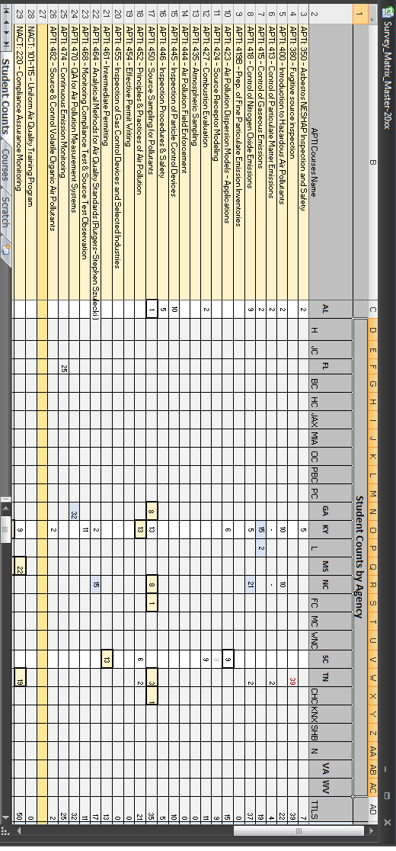
This Excel spreadsheet aids in the tabulation of the need count for each course. On the left side of the spreadsheet, courses are listed. Along the top the agencies are listed. Where the agency and course interset, enter in the student count need. The tabulations will appear in column ‘AD’ and row 68.Columns ‘A’ and ‘B’ are frozen, so you can scroll across the spreadsheet without losing sight of them. Row 1 and 2 are also frozen, so you can scroll downward. Sheet 2 (‘Courses’) of this spreadsheet lists all the courses within the catalog that Metro 4/SESARM offers.
The color coding of the individual cell are options. My system is that the blue cells are training needs that is scheduled, the yellow are the proposed training needs to watch and red need more clarification

Appendix C. File Name: Lists-Locations.docx

This file has not been built yet.
Build it from the Memeo shipping addresses for a start.

Appendix D. File Name: FieldTripTemplate.xls

This is the template a multi-visits worksheet. The image below only shows the first template for the first site visit (lines 3-12). There are 4 templates on the same Excel worksheet (lines 3-54).

The template is used to document the type of information that needs to be gathered about each field trip and in what order they need to be scheduled. Instructors will call these sites about a month before the class to confirm the visit and ensure the conditions. Sometimes instructors like to alternate days of actively teaching, so the class visit need to be scheduled to match their schedule.

Modify the original file as needed.

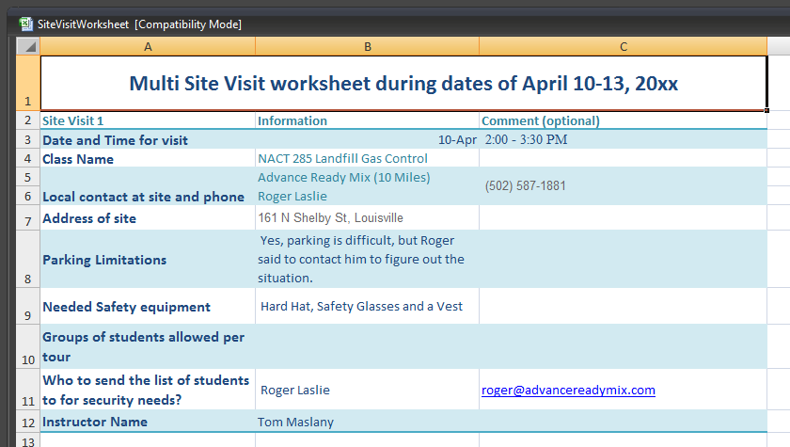

Appendix E.

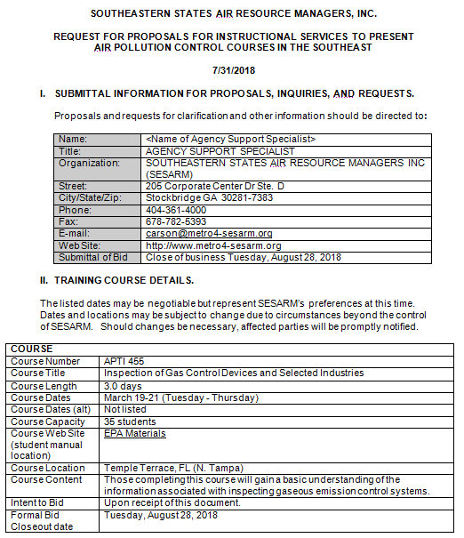

Appendix F. File Name: RFPResponseCalculator.xls

Additional lines can be added to this template for better calculation. Just ensure that the total in cell B14 equals 100%.

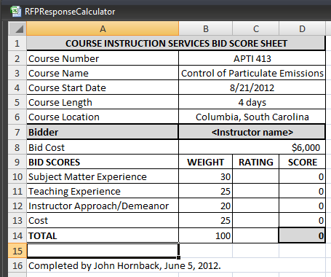

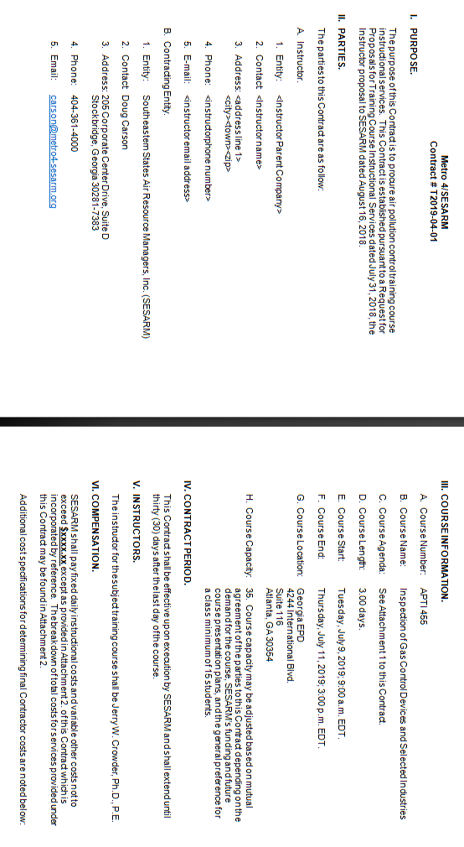
Appendix G. File Name: Contract-Template-T2019-04-01.docx
Appendix H. File Name: CheckList-ADM.docx

Check-list for things to take to ADM

 | Agendas – SESARM BOD, Metro BOD. Small Groups, Air Director Meeting |  | Speakerphone and phone wire |  | “WiFi” and password
 | Laptop |  | Batteries for microphones |  | Phone dial-out procedures
 | Projector |  | Laser pointer and batteries |  | Hotel contract
 | Microphones with receivers and cabling |  | Slice Advancer and batteries |  | BEOs
 | Mixer |  | External laptop speaker |  | Contact info
 | Extension cords and surge bars |  | Dolly |  | Attendance Roster
 | Gaffers Tape |  | Diagrams – main session and small meetings |  | Name tags
 |  |  | Conference Line #’s |  | Markers
 |  |  | Direct billing list

Appendix I. File Name: TrainingDataWHouse-Pivot.xlsx
This is a sample
